4.

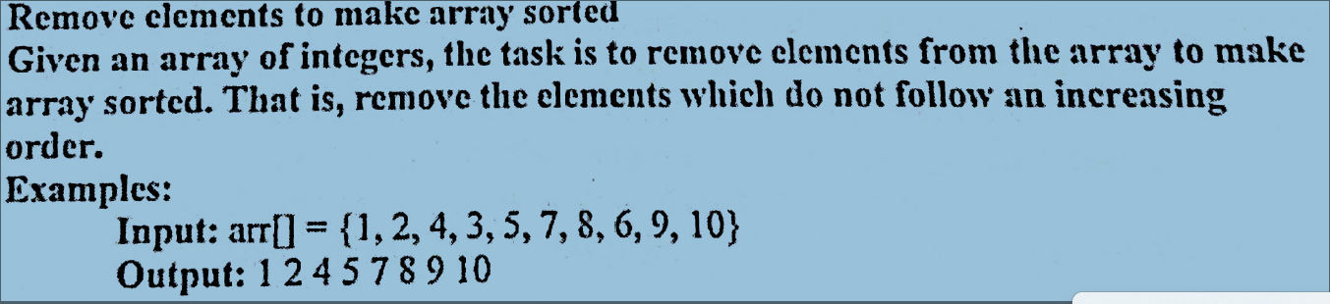

CODE:

#include <stdio.h>

// Function to sort the array

// by removing misplaced elements

void removeElements(int arr[], int n)

{

// brr[] is used to store

// the sorted array elements

int brr[n], l = 1;

brr[0] = arr[0];

for (int i = 1; i < n; i++)

{

if (brr[l - 1] <= arr[i])

{

brr[l] = arr[i];

l++;

}

}

// Print the sorted array

for (int i = 0; i < l; i++)

printf("%d ", brr[i]);

}

// Driver code

int main()

{

Int n;

printf(“Enter array size\n”);

scanf(“%d”,&n);

int arr[n];

printf(“Enter array elements\n”);

for(int i=0;i<n;i++)

scanf(“%d”,&arr[i]);

removeElements(arr, n);

return 0;

}

